泰国副总理将在天猫直播带货！传将合作中国著名网红主播推销产品

Thai Deputy Prime Minister will take the goods live in Tmall! China's famous network star anchor sales products
原创 泰国播报 2020-06-05 12:12:28
https://www.toutiao.com/i6834711805202268684/?tt_from=weixin&utm_campaign=client_share&wxshare_count=1&timestamp=1591364092&app=news_article&utm_source=weixin&utm_medium=toutiao_android&use_new_style=0&req_id=20200605213452010026059088151A781A&group_id=6834711805202268684
泰国头条新闻社讯 据泰国商务部国际贸易促进厅长颂德透露：6月9日晚19：30-20：30分，国际贸易促进厅将联合阿里巴巴旗下天猫平台进行直播卖货活动，促销泰国食品及水果。晚上19：30-20：30分这个时段是中国网民观看直播的高峰期。届时泰国副总理兼商务部长朱林 (Jurin Laksanawisit) 也将通过中文翻译人员亲自进行直播卖货，并且还将联合天猫直播平台顶级带货主播合作推广泰国食物与水果（有泰媒报道称该顶级主播为著名的女网红"雪梨"）。
Thairath Agency News According to Mr. Ekachat Seetavorarat, Thailand's Ministry of Commerce's Department of International Trade Promotion (DITP), said: June 9 evening 19:30-20:30, the international trade promotion office will be in conjunction with Alibaba's Tmall platform for live sales activities to promote Thai food and fruit. At 19:30 p.m.-20:30 p.m. this time period is the peak period for Chinese netizens to watch live broadcast. His Excellency Jurin Laksanawisi, Vice Prime Minister and Minister of Commerce will also sell the goods in person through Chinese translators, and will also work with the top lead anchor of the Tmall live broadcast platform to promote Thai food and fruit (Thai media reported that the top anchor is known as the famous lady internet star “Pear").

泰国副总理朱林 His Excellency Jurin Laksanawisi, Vice Prime Minister and Minister of Commerce

著名女网红"雪梨" The famous lady internet star “Pear"
颂德称：“阿里巴巴方面决心要把此次直播做成与泰国以往合作中最盛大的一次活动，因为此次活动与中国顶级带货女主播联手，届时在直播期间会有好几百万人来观看，这也是直播活动中一个高潮亮点，增加信誉度以吸引人们对泰国商品的关注，而在观看高峰阶段会介绍泰国最受中国观众喜爱的水果-榴莲和山竹。并且朱林副总理将会亲自剥山竹，以让中国网民了解剥山竹的方法。此次直播带货活动预计将会使得六月份的泰国水果销售额超过4亿泰铢，其中榴莲和山竹销售占2亿泰铢。”
"Alibaba is determined to make the live broadcast the biggest of its kind with Thailand in the past, because it will be watched by millions of people during the live broadcast, a highlight of the event, adding credibility to attract attention to Thai goods, and introducing Thailand's favorite fruit, durian and bamboo, during the peak viewing period ," said Sond. And Zhu Lin deputy prime minister will personally peel bamboo to let Chinese netizens understand the method of peeling bamboo. The live show is expected to bring Thai fruit sales to more than 400 million in June Thai baht, of which durian and bamboo sales accounted for 200 million baht.
“6月份贸促厅还将同天猫合作举行泰国水果、食品、饮品推销活动，着重宣传的水果有：榴莲、山竹、芒果、椰子，以及在天猫上大受欢迎的泰国食品及饮料，有200家泰国经营者一同参与选品提议。驻中国大陆和中国香港的国际贸促厅办公室还将同中国大陆及香港的进口商、大型商场合作，在各大商场内举行泰国商品宣传活动。”
"In June, the Office will also work with Tmall on the promotion of Thai fruit, food and drinks, with emphasis on durian, bamboo, mango, coconut, and popular Thai food and drink on Tmall, with 200 Thai operators participating in the selection proposal. The Office of the International Council for the Promotion of International Trade in Mainland China and Hong Kong, China, will also cooperate with importers and shopping malls in mainland China and Hong Kong to hold promotional activities on Thai goods in major shopping malls.
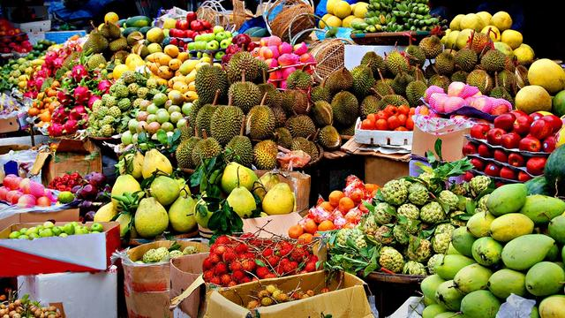
除此之外颂德先生还表示，解除疫情封锁的国家和开放让民众举行各项活动的国家，可让商务参赞同进口商、大型商场合作举行泰国商品推销活动。但是暂未开放的国家，比如暂时禁止公民出境直至年末的马来西亚，就可能会协商举行线上商务活动，或是同马来西亚商场合作举办推销活动等。
In addition, Mr. Sond said that countries that lift the epidemic blockade and those that open up activities for the population allow business counsellors to cooperate with importers and shopping malls in the promotion of Thai goods. But countries that have not yet opened up, such as Malaysia, which temporarily bans citizens from leaving the country until the end of the year, may negotiate online business activities or co-operate with Malaysian shopping malls to organize marketing activities.

